BASA Pre-boarding Screening

# Introduction

The Borealian Aeronautic Security Agency (BASA) runs pre-board screening of passengers and crew for all flights departing the nation’s airfields. Borealia has four major airfileds: Auckland, Chebucto, Saint-François, and Queenston. Each airfield conducts a similar process and records each screening. Data collected includes passenger wait-time and flight information.

# The System

Airfields conduct pre-boarding screening (PBS) of new passengers entering the Borealia, as well as passengers in transit as required. (See Figure 1)

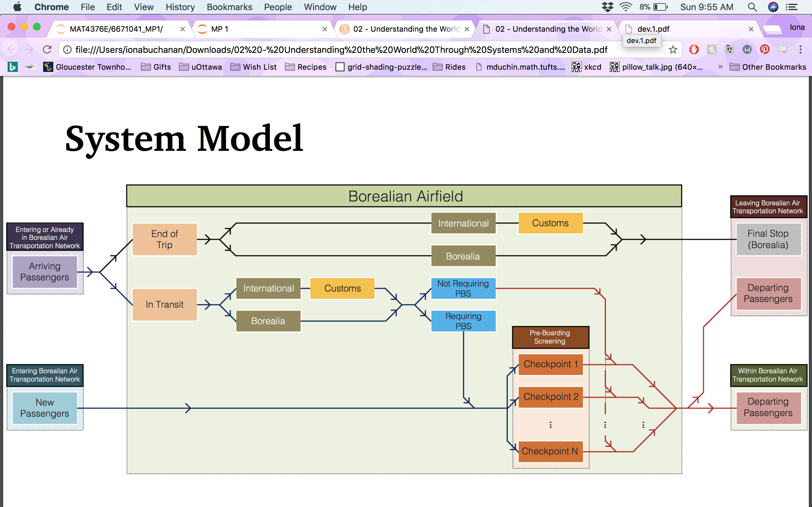

Figure System Model

## The Screening Process

Passengers enter the screening area at the beginning of the queue (), where their boarding pass may be scanned (occurs approx. 45% of the time). Once a passenger reaches the front of the queue (), their boarding pass is scanned before proceeding to a screening server.

The wait time in the queue depends on the number of departing flights, the number of passengers, and the number and efficiency of servers.

# The BASA Dataset

Flight information (scheduled and actual departure time) and passenger information (passenger ID and final destination) are collected separately at the airline level and merged by BASA. Therefore, it is possible that we will see flight information missing passenger data and passenger information missing flight data.

The following table describes each field and expected datatype and format.

Table Dataset Fields

